**A.KPI**

**1- Total Revenue**

SELECT SUM(total_price) AS Total_Revenue FROM pizza_sales

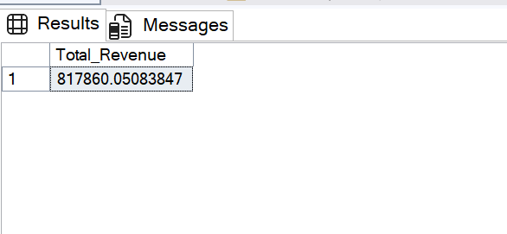

**2- Average Order Value**

SELECT SUM(total_price) / COUNT(DISTINCT order_id) AS Average_Order_Value FROM pizza_sales;

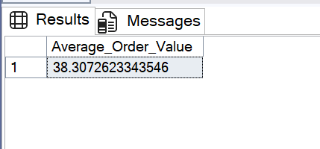

**3- Total Pizzes Sold**

SELECT SUM(quantity) as Total_Pizza_Sold FROM pizza_sales

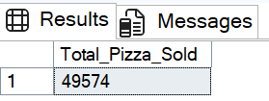

**4- Total Order**

SELECT COUNT(DISTINCT order_id) AS Total_Order FROM pizza_sales

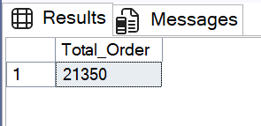

**5- Average Pizza Per Order**

SELECT CAST(CAST(SUM(quantity) AS DECIMAL(10,2)) /

CAST(COUNT(DISTINCT order_id) AS DECIMAL(10,2)) AS DECIMAL(10,2)) AS Avg_Pizza_Per_Order FROM pizza_sales

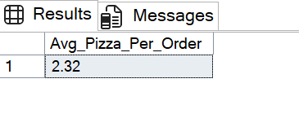

**B. Daily Trend for Total Orders**

SELECT DATENAME(DW, order_date) AS order_day, COUNT(DISTINCT order_id) AS total_orders

FROM pizza_sales

GROUP BY DATENAME(DW, order_date)

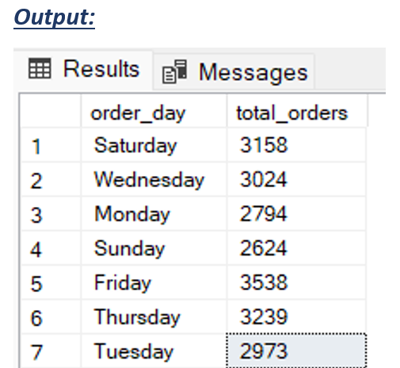

**C. Monthly Trend for Total Order**

SELECT DATENAME(MONTH, order_date) AS Order_Month,

COUNT(DISTINCT order_id) AS Total_Order

FROM pizza_sales

GROUP BY DATENAME(MONTH, order_date), DATEPART(MONTH, order_date)

ORDER BY Total_Order desc

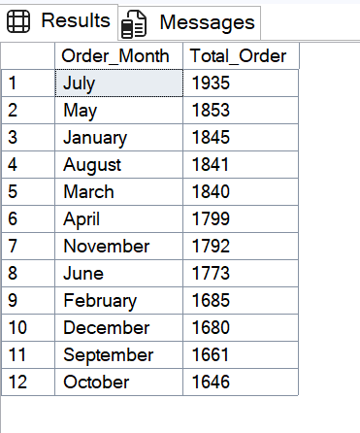

**D. % of Sales by Pizza Category**

SELECT pizza_category, CAST(SUM(total_price) AS DECIMAL(10,2)) as total_revenue,

CAST(SUM(total_price) * 100 / (SELECT SUM(total_price) from pizza_sales) AS DECIMAL(10,2)) AS PCT

FROM pizza_sales

GROUP BY pizza_category

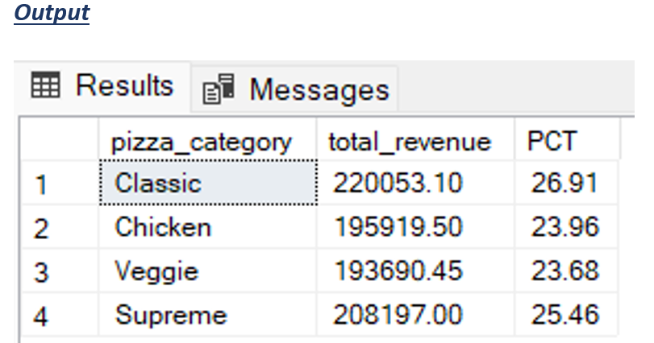

**E. % of Sales by Pizza Size**

SELECT pizza_size, CAST(SUM(total_price) AS DECIMAL(10,2)) as total_revenue,

CAST(SUM(total_price) * 100 / (SELECT SUM(total_price) from pizza_sales) AS DECIMAL(10,2)) AS PCT

FROM pizza_sales

GROUP BY pizza_size

ORDER BY pizza_size

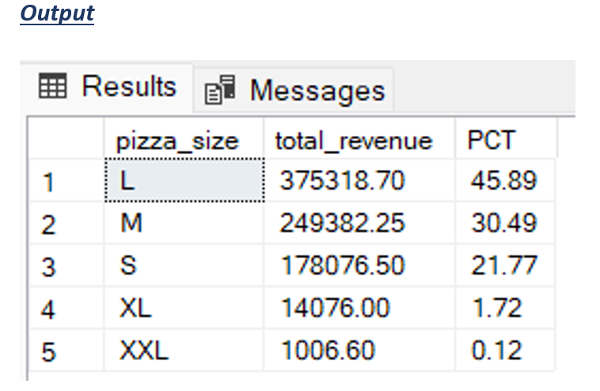

**F. Total Pizzas Sold by Pizza Category**

SELECT pizza_category, SUM(quantity) as Total_Quantity_Sold

FROM pizza_sales

WHERE MONTH(order_date) = 2

GROUP BY pizza_category

ORDER BY Total_Quantity_Sold DESC

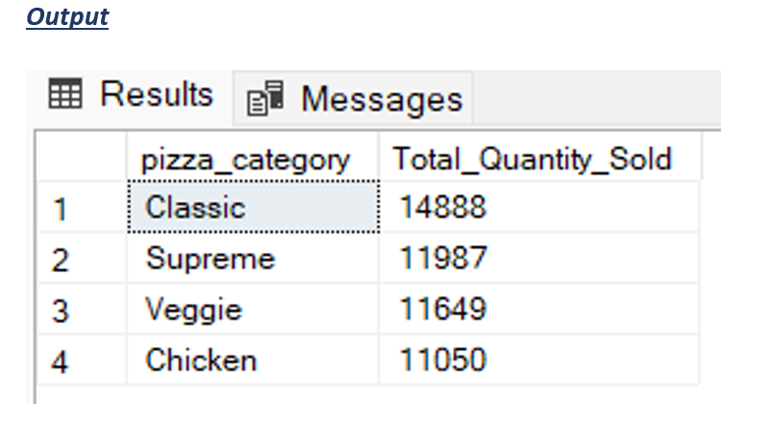

**G. Top 5 Pizzas by Revenue**

SELECT Top 5 pizza_name, SUM(total_price) AS Total_Revenue

FROM pizza_sales

GROUP BY pizza_name

ORDER BY Total_Revenue DESC

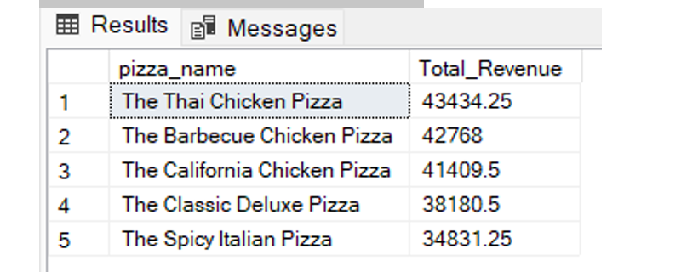

**H. Bottom 5 Pizzas by Revenue**

SELECT Top 5 pizza_name, SUM(total_price) AS Total_Revenue

FROM pizza_sales

GROUP BY pizza_name

ORDER BY Total_Revenue ASC

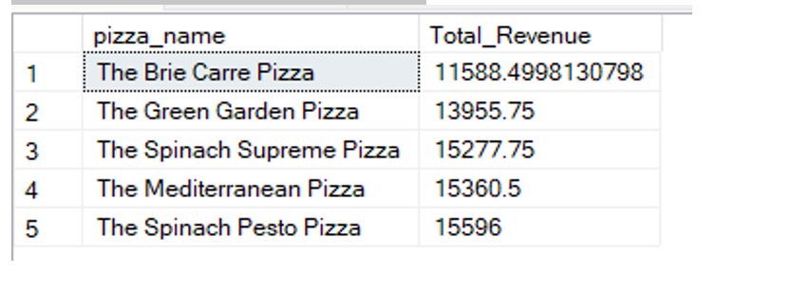

**I. Top 5 Pizzas by Quantity**

SELECT Top 5 pizza_name, SUM(quantity) AS Total_Pizza_Sold

FROM pizza_sales

GROUP BY pizza_name

ORDER BY Total_Pizza_Sold DESC

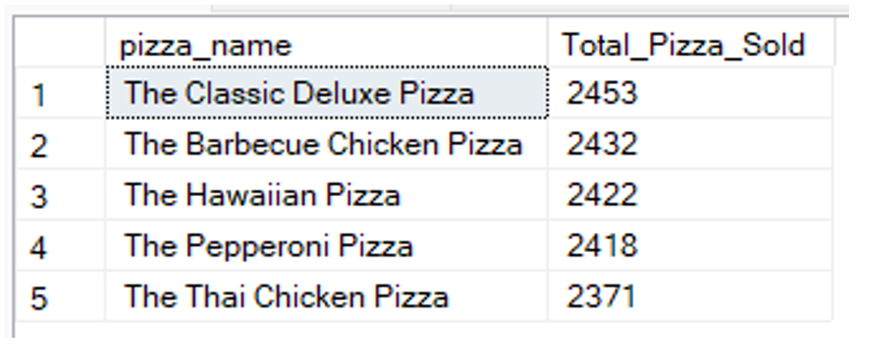

**J. Bottom 5 Pizzas by Quantity**

SELECT TOP 5 pizza_name, SUM(quantity) AS Total_Pizza_Sold

FROM pizza_sales

GROUP BY pizza_name

ORDER BY Total_Pizza_Sold ASC

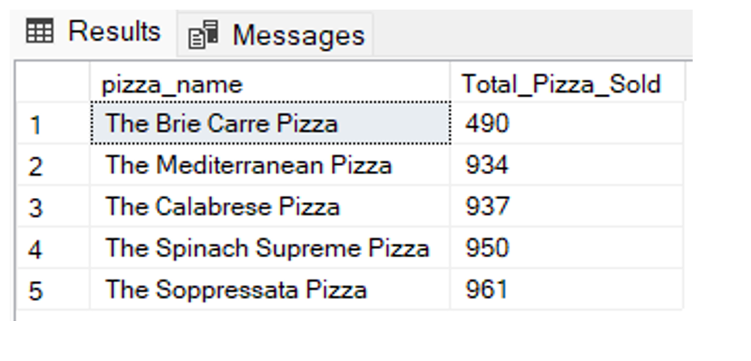

**K. Top 5 Pizzas by Total Orders**

SELECT Top 5 pizza_name, COUNT(DISTINCT order_id) AS Total_Orders

FROM pizza_sales

GROUP BY pizza_name

ORDER BY Total_Orders DESC

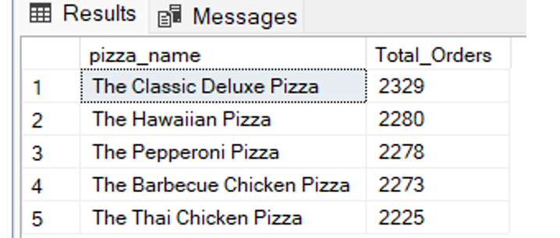

**L. Borrom 5 Pizzas by Total Orders**

SELECT Top 5 pizza_name, COUNT(DISTINCT order_id) AS Total_Orders

FROM pizza_sales

GROUP BY pizza_name

ORDER BY Total_Orders ASC

